Assignment 4.1
16-bit ALU

Introduction: -
ALU_TOP is the fundamental building block of the processor, which is responsible for carrying out different functions: -
- Arithmetic functions through ARITHMETIC_UNIT block.
- Logic functions through LOGIC_UNIT block.
- Shift functions through SHIFT _UNIT block.
- Comparison functions through CMP_UNIT block.
And Decoder Unit responsibles for enable which Function to operate according to the highest Most significant 2-bit of the ALU_FUNC control bus ALU_FUNC [3:2].

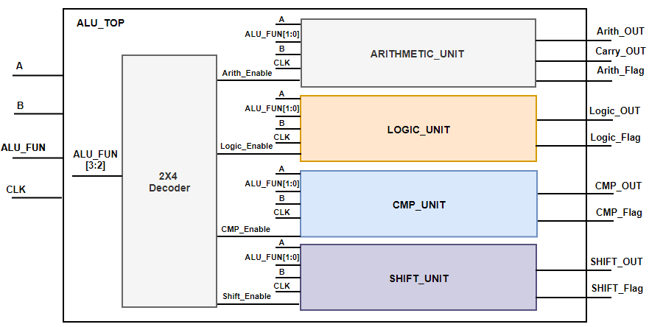
Block Diagram

TOP Module (ALU_TOP) Port Description:
Width (bits) | Signal Name
parameterized | A
parameterized | B
4 | ALU_FUNC
1 | CLK
parameterized | Arith_OUT
1 | Carry_OUT
1 | Arith_Flag
parameterized | Logic_OUT
1 | Logic_Flag
parameterized | CMP_OUT
1 | CMP_Flag
parameterized | SHIFT_OUT
1 | SHIFT_Flag

Specifications: -
- All Outputs are registered.
- Arith_flag is activated "High" only when ALU performs one of the arithmetic operations (Addition, Subtraction, Multiplication, division), otherwise "LOW"
- Logic_flag is activated "High" only when ALU performs one of the Boolean operations (AND, OR, NAND, NOR), otherwise "LOW"
- CMP_flag is activated "High" only when ALU performs one of the Comparison operations (Equal, Greater than, less than) or NOP, otherwise "LOW"
- Shift_flag is activated "High" only when ALU performs one of the shifting operations (shift right, shift left), otherwise "LOW"
- The ALU function is carried out according to the value of the ALU_FUN input signal stated in the following table.
ALU_FUN Table
ALU_OUT | Operation | ALU_FUN
 | Arithmatic : Addition | 0000
 | Arithmatic : Subtraction | 0001
 | Arithmatic : Multiplication | 0010
 | Arithmatic : Division | 0011
 | Logic : AND | 0100
 | Logic : OR | 0101
 | Logic : NAND | 0110
 | Logic : NOR | 0111
Equal to 0 | NOP | 1000
Equal to 1 | CMP: A = B | 1001
Equal to 2 | CMP: A > B | 1010
Equal to 3 | CMP: A < B | 1011
 | SHIFT: A >> 1 | 1100
 | SHIFT: A << 1 | 1101
 | SHIFT: B >> 1 | 1110
 | SHIFT: B << 1 | 1111

Hint: Use Case statement to describe the behavior of this table and use default case if needed.
Hint: You can use if statement inside case branches.
Note: Arith_Enable, Logic_Enable, SHIFT_Enable and CMP_Enable are called block enable which responsible for enabling the function of the block or not.

Decoder Truth Table
SHIFT_EN | CMP_EN | Logic_En | Arith_En | ALU_FUNC[3:2]
0 | 0 | 0 | 1 | 00
0 | 0 | 1 | 0 | 01
0 | 1 | 0 | 0 | 10
1 | 0 | 0 | 0 | 11

Hint: How to use the enable signal inside the code of each block.

always @(*)
begin
if(Arith_Enable)
begin
case(ALU_FUN)
2’b00 : {ALU_Carry, ALU_Arith } = A + B ;
………..
endcase
end
else
begin
ALU_Arith = 16’b0 ;
End
End

Requirements: -
- Write a Verilog Codes of the following 6 modules
  - ARITHMETIC_UNIT
  - LOGIC_UNIT.
  - SHIFT _UNIT
  - CMP_UNIT
  - Decoder Unit
  - ALU_TOP
- Write a testbench to test all the ALU functions with operating clock frequency 100 KHz with duty cycle 40% low and 60% high
